The Marketing Maturity Model
A METHOD FOR ASSESSING AND OPTIMIZING MARKETING EFFECTIVENESS FOR
B2B TECHNOLOGY COMPANIES

Ken Chow
Growth Curve Marketing, LLC

Overview
For any technology company, the road to success is fraught with obstacles. From bad timing to poorly designed products and under-capitalization, there are challenges across every facet of the operation. The role of marketing has been receiving increasing attention among leaders and investors, in part due to the dominance of the SaaS model where growth in the number of active users – driven by demand generation – is the difference between life and death.
Marketing’s contribution to success evolves at each stage of growth. For instance, in the earliest phases, “marketing” is focused largely on driving interactions with prospects in the target market to better guide the development of the initial product to a market-acceptable state. Later, as the company works to develop a repeatable sales process, marketing must be primarily focused on sales support and demand generation. Finally, when the company makes it to the latest stages of maturity, counter-competitive programs and channel development dominate marketing’s plate.
When marketing fails to properly execute on these objectives, it often stems from lack of experience, an/or failure to focus on key activities and related metrics appropriate for each stage. While it can be difficult to find and acquire effective marketing talent at any stage, in the earlier phases of a company’s growth, such expertise may simply prove unaffordable on a full-time basis. Alternately the marketing staff that you can afford may lack the expertise required to be effective.
Early stage companies can increase their growth rate at each stage and proceed more quickly to a successful exit by utilizing senior marketing leaders on an affordable, fractional basis to execute a plan that employs the objectives, practices, and metrics appropriate for each stage following the marketing maturity model.

The Maturity Model
The Marketing Maturity Model breaks down the evolution of a B2B technology company into four discrete phases, each with specific marketing objectives, related activities, and key metrics:
Phase | Description | Overall Marketing Objective
Incubation | From creation to Minimal Acceptable Product, the company seeks to refine and validate its technology. | Engage representative early adopters to guide product development and create first-stage customers.
Go-To-Market | First generation product and support elements are in place as the company seeks to create a repeatable business model. | Create and refine positioning, packaging, pricing, and demand generation that satisfies the evolving sales model.
Scaling | With a refined selling process, the company begins to scale the business model across sales, support, and marketing. | Establish high-volume lead generation to meet sales projections, and become a widely recognized brand.
Capture | As one of only a handful of market leaders, the company works to Capture dominant market share, seize from and deny share to competitors, and establish an effective presence in all markets, geographic, vertical, and otherwise. | Enact effective counter-competitive campaigns, and complete segment and territory coverage across all marketing programs.

Schematically, the Maturity Model describes the progression of the company on a timeline, along with the primary marketing goals, the key metrics, and the decline that may occur due to failure of marketing:
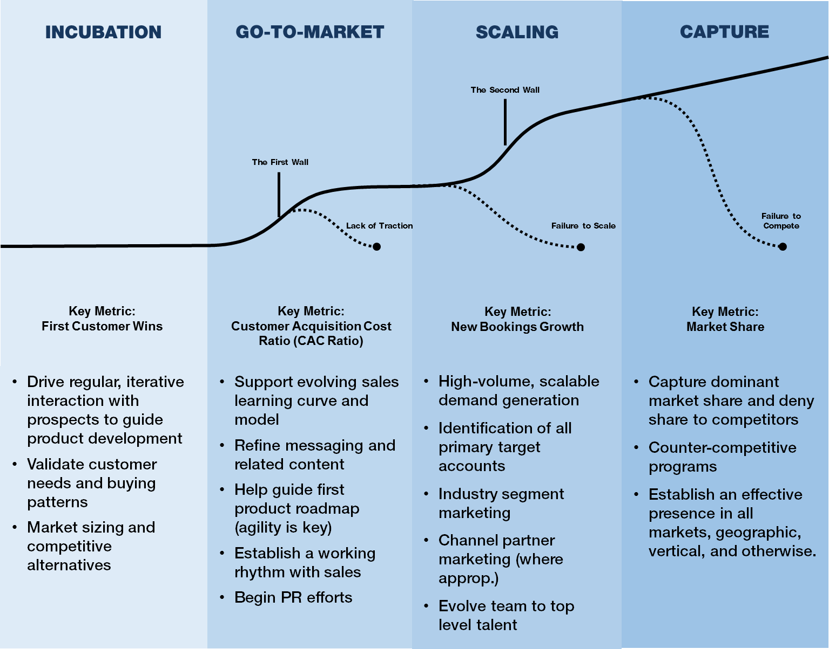
While the model is neatly divided into phases, some companies may find themselves in transition, with a foot in both, as it were. Some companies may “pivot” to alternate markets or applications, and find themselves regressing back to an earlier phase.

Marketing’s Role: Activities and Metrics by Phase
The specific activities for effective marketing practice at each stage are numerous. The following describes them in general terms.

Incubation

Overview of Activities
At this stage, marketing may not exist as a formal function, and is often a shared responsibility among the founders. Nonetheless, there are critical marketing objectives that are essential in guiding and validating the assumptions that drive product creation:
- Drive Regular, Iterative Interactions with Prospects – Marketing should drive meetings with prospects (“early adopters”) to provide a feedback loop to guide the product development process, and documenting customer needs and requirements.
- Research Market Size, Competitive Environment, And Exploitable Opportunities. This should feed back into customer interactions for validation and expansion.
The above processes must have the direct involvement of the CEO. Ideally he/she leads this process. The simple fact is, as brilliant as a technology may be, it is the customers who make us “smart” by guiding and validating our assumptions.

Key Operating Metrics
While few formal metrics are applicable at this stage, there are some objective measurements that should be watched:
- Number of Prospect Interviews – Obviously, this number should be as large as practical (one is never good, but is all too often the number used in many startups)
- Prospect Representation – the prospects interviewed should be representative of all of the targeted segments. Again, this may seem obvious, but I’ve seen assumptions acting as a proxy for data, and it usually makes for unpleasant surprises.
- Number of Assumption Proven False – each assumption contradicted by customers should be carefully considered. This can tell you how effective your data gathering and validation is, as well as how sound initial assumptions were.

Go -To-Market

Overview of Activities
It is during this phase that the selling process begins to develop in earnest, as the company seeks to create a repeatable, sustainable, business model. It is arguably the most dangerous period for the company, for if a sustainable model can’t be found, it may be an indication of an unviable product or market strategy.
Once the company begins reaching out to and engaging with the “early majority” (as Geoff Moore terms it) they must ascend the sales learning curve quickly in order to achieve a viable win rate and contact-to-close sales cycle. Marketing must likewise evolve their lead generation capabilities to feed the required pipeline – which may be less efficiently used by sales early on – as well as provide effective tools and other support to the sales team. And all of this must be done with a mind towards scalability, which will dominate the next phase. The priority for marketing must be to drive “ready-to-eat” sales opportunities; everything else is secondary. Marketing leadership may not be highly experienced, but they must be well-versed in basic operational marketing, and given to a highly flexible, cooperative, and unflappable nature. They will likely benefit from education and consultative help.
- Develop Effective and Structured Lead Generation Programs – These must meet revenue goals. Without structure, the programs may not prove viable in the next phase.
- Effective Working Rhythm with Sales – (lead delivery and nurturing process)
- Implement Marketing Automation Infrastructure – that not only tracks effectiveness but also costs.
- Messaging Platform (Message Map) – This must include the problem, it’s implications, why your product is the best way to solve it, and exactly how it works (see content library, below). A Unique Selling Proposition (USP) should become the company’s mantra.
- Basic Competitive Intelligence – marketing should regularly monitor top competitors for messaging, counter-positioning, and pricing.
- Build Content Library to Cover the Buying Cycle:
  - Awareness and Attention – attention getting format, focus on problem not just product
  - Understanding and Belief – explanation of how the product works and examples of peer successes
  - Desire and Action – detailed descriptions of implementation, support, pricing, and purchasing process.
- Gather Customer Feedback and Perform Win/Loss Analysis – I group these together because this is a function that should include sales input, but should not be handled by sales. Not only does it take time away from selling, the feedback one gets from sales on why their efforts have failed might be colored by their role in the process. Moreover, prospects and customers are often more willing to give honest feedback to someone they perceive as not having a financial stake in their reactions.
- Begin to Build Out the Marketing Team – with demands on marketing building, it’s important that you not get too far behind the hiring curve, as it can lead to poorly considered hires. Experience and demonstrable competence with the domain of their responsibility is important, but so is willingness to learn and take on additional duties.
- Full-Blown PR/Analyst/Pundit Outreach and Influence Efforts – In many markets, customers seek out analyst reports as a way of “short-listing” vendor selection. Pitching and influencing analyst opinion requires not merely cultivating a relationship, but building content and programs to provide them the data they require to validate your position.

Key Operating Metrics
For the above activities, two metrics are vital:
- Opportunity Production – the standard funnel models focus on “leads”, “sales qualified” and “marketing qualified”. There’s nothing wrong with these as metrics in themselves, but they are still sufficiently removed from the sales cycle as to be of limited use outside of marketing, and do little to measure the effect of marketing on revenue. It is imperative to measure opportunities as defined by the selling model. This typically means having a contact of requisite buying authority within a firm in the target market who has engaged with the company, expressed an interest in acquiring a product in the category, and who will take a call from sales. Opportunities can be directly tied to revenue:
(Opp) * (Win Rate) * (ASP) = Gross Revenues
Thus, not only can marketing’s contribution to company revenues be better assessed, but the fates of sales and marketing are tied, leading to a more cooperative relationship. It should be noted that the requisite production targets must be made by factoring in the average selling cycle and revenue recognition. For instance, a 90-day selling cycle demands that the opportunities produced in Month 1 support the revenue target for Month 4.
Note – for marketing, tracking opportunity production implies the tracking of all key deliverable above it in the funnel: impressions, engagements, leads, etc.
- Customer Acquisition Cost (CAC) Ratio – One marketing metric has received a lot of attention as a result of the SaaS revolution: the CAC Ratio. This is used to calculate the period required to recoup sales and marketing expenses. In SaaS models, the LTV is spread more or less evenly (not allowing for upsell) over (typically) a few years, and so the payback of sales and marketing costs must be measured against the gross margins produced over time. Again, depending on the sales cycle involved, the marketing spend relevant to the increase in gross margins that it generates will precede it by that period. Thus, for a 90 day sales cycle, the CAC ratio for a given quarter is the annualized net gross margins for that quarter divided by the sales and marketing costs that drove the opportunities for that quarter (per Bessemer):
CAC Ratio (Q4) = [GM (Q4) – GM (Q3] *4 / Sales and Marketing Costs (Q3)
For non-SaaS (transactional) models, the numerator would include the annualized net gross margins for that quarter plus the annualized margins on maintenance or other subscription fees.
In the SaaS model, this ratio for successful companies typically varies between 0.5 and 1.0, corresponding to a payback period of two years and one year, respectively.
In a non-SaaS model, where the majority of the LTV is booked at the time of the transaction, this picture is less clear, but a considerably higher CAC Ratio would obviously be called for. This target ratio is dependent on the average customer lifetime, the percentage of revenues derived from subscription, as well as the COGS profile of the company.
Note – for both types of models, tracking CAC Ratio implies the tracking of all other related marketing cost indices, e.g. cost per engagement, cost per lead, etc., by campaign and channel.
It should be noted that some pundits suggest that investing more in inbound marketing is one way to positively affect the CAC ratio as it represents a more cost-effective approach. I have found this to be a very dangerous assumption for many companies, particularly those with even modestly complex value propositions or mid-5+ figure price points, where inbound mechanisms simply aren’t well-suited to conveying the value proposition. Another disadvantage of inbound channels – advertising networks, PPC, Adwords, etc. – is that they have become very efficient markets, where competing for eyeballs with competitors in markets of any size can only be scaled so far before becoming costly. Moreover, many sales teams are not used to, or trained in, lead-to-opportunity development, and often lack the skills necessary to do the outreach needed to convert interested prospects. This is one of the reasons there has been growth in outbound led development services and technologies (Vorsight, Memory Blue, BAO, Connect and Sell, etc.). One of the most effective things that companies with complex sales or high price points can do to prepare for the next phase – Scaling – is to develop an ISR (Inside Sales Rep, aka Business Development Rep) function that serves as an outbound lead development engine. This may even reside in the sales team itself, though many firms have found success with separate teams, in some cases the BDR teams acting as a “farm system” for developing sales reps. Too often, leads lay fallow without this lead-to-opportunity bridge.

Scaling
Overview of Activities
All the above, plus:
Once the company emerges from the Go-to-Market phase with a repeatable, scalable selling model, marketing now faces the work of scaling demand generation to feed a steeper revenue growth curve. For those companies that haven’t developed a scalable model, a premature investment (usually quite sizable) in scaling can be disastrous. Many companies are ill-prepared for this, and come to realize that while they may have been able to serve sales demands up to this point, they lack a programmatic demand generation process, marketing infrastructure, skillsets, or all three. That’s why it’s so important to lay the foundations for scalability during the prior Go-to-Market phase. If that hasn’t been done, an accelerated program to bring the requisite structure may be needed. This phase is where relentless execution becomes the watchword, because at this pace, any inattentiveness can put you way behind. That is why marketing leadership as well as staff must, by this stage, be highly experienced in all aspects of demand generation and sales support. In some cases, leadership might come from evolving the existing talent, but more often than not, it involves recruiting. If the company cannot find this leadership quickly enough, they should exploit resources from the BOD, outside consultants, or even lead generation firms (who, in my experience, are a mixed bag, at best).
- High-Volume Demand Generation – this requires marketing automation (CRM) well-integrated with any sales automation system (e.g. salesforce) - see below. The related activities notably include regular, rigorous A/B testing of different content and methods, thorough data collection and measurement, and requisite skill sets to set up and manage it.
- Close Day to Day Connection with Sales – as the pressure mounts and activity rates increase, it’s all too easy for sales and marketing to disconnect, and even come into conflict with each other. In addition to a shared metric (Opportunity Production), the respective teams should regularly come together to review the entire process “from stranger to customer”, exchanging ideas and committing to mutual support. The respective leaders, of course, should be joined at the hip all the time, but I’ve been surprised by the number of companies where there is no regular interaction between the marketing staff and the sales team.
- Identification of All Primary Target Accounts (aka “Universe Building”) – In order to systematically exploit the addressable market, you must know who each and every prospect is. There are many ways to do list-building, and costs vary by industry and decision maker level, but at the very least, the company must have the company names and basic data for their market. In addition to the obvious, this allows the company to choose the “low-hanging fruit” as defined by the most desirable size, industry, geography, etc.
- Channel/Partner Marketing – In those segments where local presence, specialized expertise, or existing relationships call for selling through channel partners, marketing must be ready to provide the tools, content, and even demand generation assistance needed to make these channels viable and productive.

Key Operating Metrics
As before, the main metrics remain Opportunity Production and CAC Ratio. In addition, the team should begin tracking:
- New Bookings Growth – While upsell and retention is still a part of marketing’s charter, the main focus in Scaling must obviously be new bookings.
- Channel Contribution – the relative revenue contribution of each channel partner should be tracked to measure growth and rank effectiveness.
- Estimated Market Share – as determined by the number of customers divided by the total addressable market as determined in the “Universe”. This may also be broken down by segment, and augmented with analyst data. This can help determine progression through the market, as well as weaknesses and opportunities to be addressed.
- Public Presence – mentions, lead coverage, and other citations in press, social, and analyst content should be tracked for the company as well as key competitors to determine relative mind share.

Capture

Overview of Activities
All the above, plus:
Once the company matures to reach a rate of market capture equal to the top three or four competitors, the focus begins to include displacing these firms – winning customers away from them and denying access to territory or segments.
- Implementing Counter-Competitive Campaigns – Marketing should look to neutralize any claims, promotions, or activities by major competitors. This might even be done in a way to leverage publicity paid for by the competitor, e.g. – coopting or contrasting positioning or related phrases used by competitors. This is especially important if the company begins to experience losses due to such competitive programs – another important reason to continue to perform regular, thorough customer feedback and win/loss surveys.
- Geographic Territory Development – As an extension of Channel/Partner Marketing, the company must establish a presence in earnest in all the key geographies in the addressable market. International sales and marketing development is a complex, varied, and usually very expensive proposition, and so the company should seek out the expertise required to make these forays successful.
- Expanded Public Presence – Expanding advertising, PR, analyst outreach, and social responsibility profile become important facets of marketing. For public companies this must be handled with extraordinary care.

Key Operating Metrics
By this time, all basic operational marketing metrics should be in place.

The Authors Approach
In establishing effective marketing practices at each phase, my approach focuses on improving four distinct areas:
- Messaging & Content – Getting the attention of customers, analysts, or investors begins and ends with effective storytelling. For prospects, you must deliver content that leads them through the buying cycle. for investors, you must communicate direction and momentum, and ability to scale, and for analysts and editors, you must provide them news that gives them useful content. One area of messaging that I find absent in an alarming number of firms is differentiation as expressed in a unique selling proposition. This seems elementary – and it is – yet it is too often absent from the company messaging.
Constructing effective messaging starts and ends with knowing the audience. By performing regular, thorough interviews with customers, and with all the people in the company that talk to them (sales, support, service, etc.), you can derive the information needed to create a set of tools to help generate effective messaging:
  - Customer Profile - Describes all of the personas - influencers and decision makers - in your selling cycle, the problems they're trying to solve, their likes and dislikes, their buying criteria, and how they view products like yours.
  - Message Map - Lays out your story and serves as the guide for all content. It describes the market, the problem you solve, how you solve it, and your unique selling proposition. It provides the specific phrases, descriptions and points that will consistently drive understanding to your audience. It may (and probably should) evolve over time, but the exercise should be started early and reviewed often. Used as a template, it greatly eases the process of content production and enforces the consistency that over time equates to a memorable identity.
  - Content Plan - Lists specific pieces to be produced and used in lead generation (email, video, graphics, documents, etc.) along with creative concepts and themes to tie them together. It also contains suggested outlines for sales, analyst, and investor tools and presentations.
- Planning and Execution – In order to sustain the required flow of leads, marketing has to execute and measure their success against a detailed set of schedules, metrics, and associated costs. Begin with your revenue targets, selling cycle, and lead conversion rates to derive a lead generation schedule that meets revenue targets. From there, create lead generation "Playbooks" (typically a spreadsheet, but increasingly a function within some CRM systems) which include specific campaigns, calendars, team responsibilities (see below) and target metrics based on your requirements.
- Infrastructure & Automation – To accomplish the planning and execution described above, it's critical that marketing automation systems are set up and integrated in a way that marketing can easily test their plans, execute them, and measure the results. Your CRM and SFA systems should include integration paths that allow them to work together, and create reporting functionality that provides insight into both marketing’s production as well as sales’ follow-up. Many companies don’t take advantage of these features, and end up using them as little more than “batch and blast” email platforms. Even worse, without usable reporting, marketing has no idea what’s working and what isn’t, or what their costs and related contributions are. In early stages, this integration may be very basic, perhaps done by a vendor or consultant. In more mature firms, it’s often useful to have in-house expertise that can create and maintain these systems.
- Team & Roles – Modern marketing has a lot of moving parts, and for the marketing team to be effective there must be a clear assignment of complementary roles filled by people with the right skills. Unfortunately, these skills are often hard to find because they're really not formally taught, they're usually acquired over careers. This is why marketing hires should be carefully vetted by someone experienced evaluating the suitability of applicant skillsets. This is not to say that there shouldn’t be cross-domain expertise, quite the opposite. Team members should be taught multiple functions over time where possible. This gives the marketing leader more flexibility in applying resources and usually makes for a more professionally satisfied and engaged team. My approach entails defining roles, creating both individual and shared responsibilities, and cross-training team members.
In terms of my overall methodology, my approach comprises four distinct stages:
- Gap Assessment – Time spent fixing the wrong problem is wasted, so I begin by performing a thorough assessment that includes an examination of all marketing materials and activities, the company’s sales pitch, and interviews with all relevant team members, including sales and product where applicable. From there I produce a structured report detailing the current state, the future desired state, and all existing gaps and what is required to fill them.
- Prioritized Project Plan – In every case, time is of the essence, and so my project plans are prioritized – focusing first on the things that will quickly move the needle and accelerate growth. A complete timeline with deliverables, milestones, and projected costs are mapped to this prioritized plan.
- Execution and Reporting – as the program plan is implemented, weekly progress reports are provided to detail completed tasks, open items, costs incurred, and performance against plan.
- Success Assessment and Assurance – Upon completion of the project plan, I provide an assessment of performance against plan, including all relevant metrics, a projected growth timeline based on these improvements, and suggested actions to maintain the growth rate.

About the Author
Ken Chow is a veteran of B2B technology marketing, having lead teams in start-ups (including his own), mid-sized firms, and world-leading companies to successful exits in a career spanning 30 years ranging from the Silicon Valley to the Mid-Atlantic. He is the founder of Growth Curve Marketing, an agency that specializes in helping B2B technology companies develop effective, sustainable marketing practices that support their growth strategies.
You can find out more about ken at Growth Curve Marketing, LLC:
www.growthcurvemarketing.com

